1.QUESTION: WRITE A C PROGRAM TO FIND THE NUMBER OF DIFFRENT BANGLADESHI TAKA NOTE FROM AN INTEGAR NUMBER.
1.ANSWER:
# C PROGRAMMING With Output:

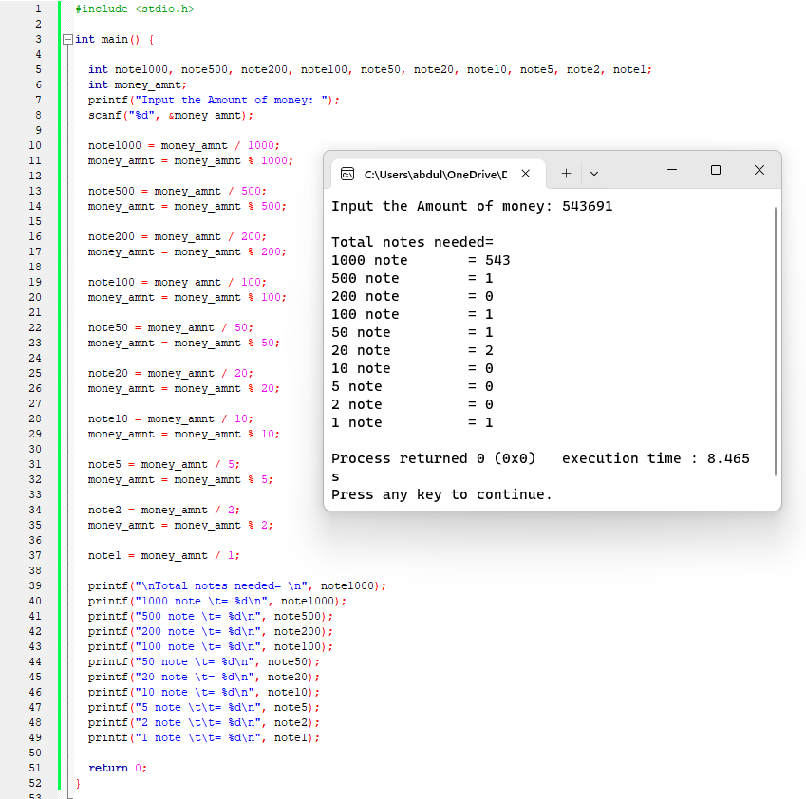

2.QUESTION: WRITE A PROGRAM IN C TO CONVERT YOUR HEIGHT FEET AND INCH INTO CENTIMETER.
ANSWER:
# C PROGRAMMING With Output

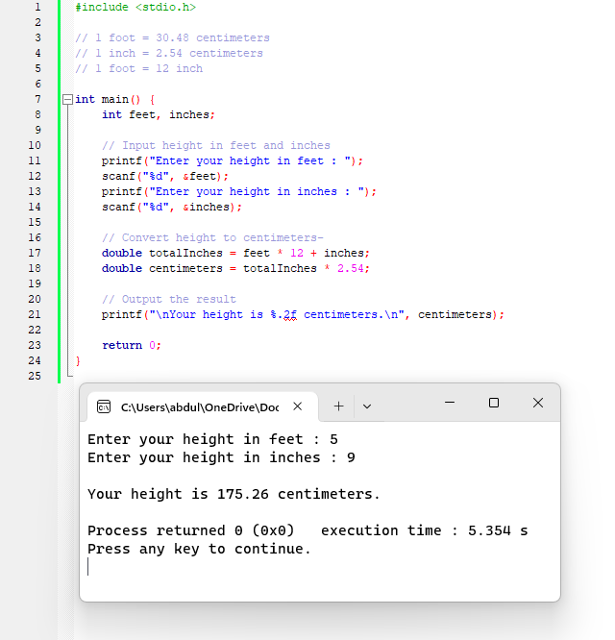

3.QUESTION: WRITE A PROGRAM IN C TO CONVERT YOUR HEIGHT CENTIMETER INTO FEET AND INCH.
ANSWER:
# C PROGRAMMING With Output
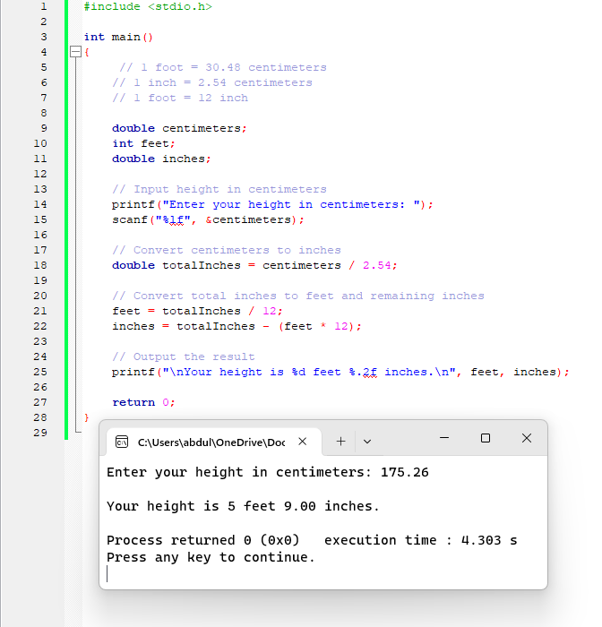

4.QUESTION: WRITE A PROGRAMM TO SEE THE ASCII VALUE OF A CHARACTER.
ANSWER:
# C PROGRAMMING With Output
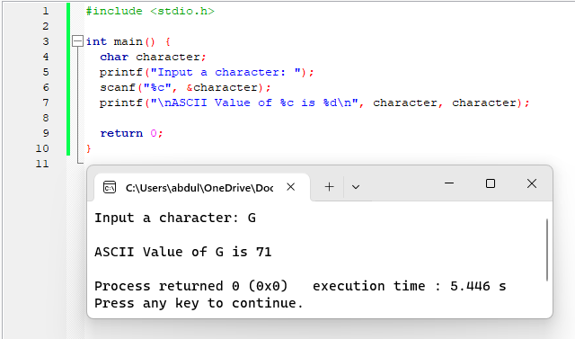

5.QUESTION: WRITE A PROGRAMM TO FIND CHARACTER FROM ASCII VALUE.
ANSWER:
# C PROGRAMMING With Output
